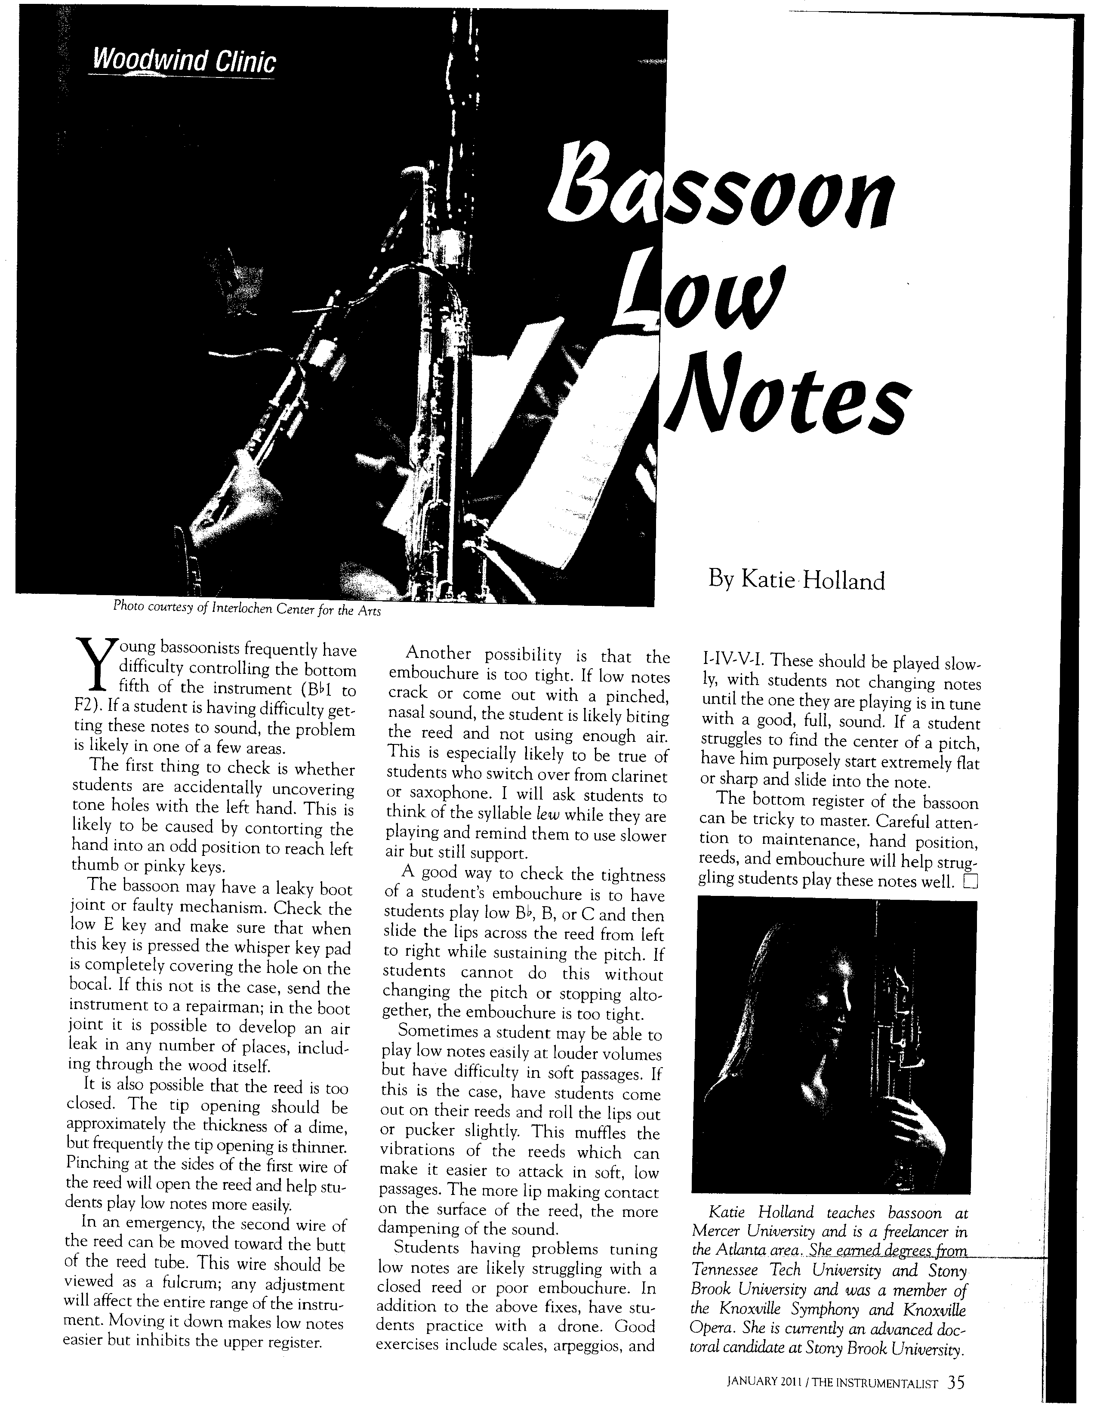
Photo courtesy of Interlochen Center for the Arts

